Chapter 3 Question 15 - Michael Streyle

##   
## Call:  
## lm(formula = concentration ~ time)  
##   
## Residuals:  
## Min 1Q Median 3Q Max   
## -0.5333 -0.4043 -0.1373 0.4157 0.8487   
##   
## Coefficients:  
## Estimate Std. Error t value Pr(>|t|)   
## (Intercept) 2.5753 0.2487 10.354 1.20e-07 ***  
## time -0.3240 0.0433 -7.483 4.61e-06 ***  
## ---  
## Signif. codes: 0 '***' 0.001 '**' 0.01 '*' 0.05 '.' 0.1 ' ' 1  
##   
## Residual standard error: 0.4743 on 13 degrees of freedom  
## Multiple R-squared: 0.8116, Adjusted R-squared: 0.7971   
## F-statistic: 55.99 on 1 and 13 DF, p-value: 4.611e-06

## (Intercept) time   
## 2.575333 -0.324000

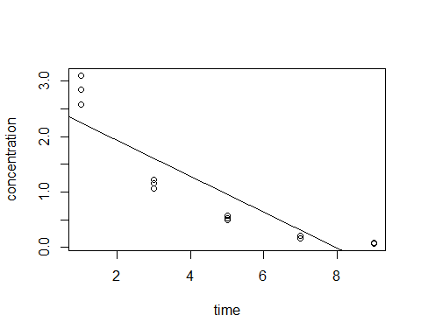

## Analysis of Variance Table  
##   
## Model 1: concentration ~ time  
## Model 2: concentration ~ 0 + as.factor(time)  
## Res.Df RSS Df Sum of Sq F Pr(>F)   
## 1 13 2.9247   
## 2 10 0.1574 3 2.7673 58.603 1.194e-06 ***  
## ---  
## Signif. codes: 0 '***' 0.001 '**' 0.01 '*' 0.05 '.' 0.1 ' ' 1

## [1] 38.50633

Chapter 3 Question 15

a) See the knitted plot. The function is Ŷ = -0.324000(X*i* ) + 2.575333.

b) The alternatives for the F test for lack of fit are *H0*: *E{Y} = β0 + β1X* and *Ha*: *E{Y} ≠ β0 + β1X*. The decision rule is then if F* ≤ F(1 – α; c -2, n -c), conclude *H0* and if F* > F(1 – α; c -2, n -c), conclude *Ha*. Here, c = 3 for the 3 subgroups, n = 5 for the number of observations in each subgroup, and α = 0.025. Here, F() = F(0.975, 1, 2) = 38.50633. The F* value from the ANOVA table is 58.603. Since 58.603 > 38.50633, I conclude *Ha ,* that the regression function is not linear. The P-value for this test is 1.194e-06.

c) From the comments section on page 127 of the book, comment 6 states that “The alternative *Ha* includes all regression functions other than a linear one. For instance, it includes a quadratic function or a logarithmic one. If *Ha* is concluded, a study of residuals can be helpful in identifying an appropriate function”. The F* test for lack of fit only indicates that the appropriate regression function is NOT linear, but does not suggest a more appropriate function.